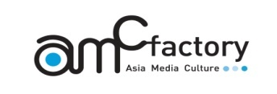“2nd Seoul Migrant Art Festival, Music & Dance Prism” Application
Team Title |  |  | English |  |  |  |  |  |  | No. |  | Do not write
Korean
(If any)
City  Country |  |  |  |  |  | Genre | □ Fusion Music □ Cross over □ Dance □Performance  □ World Music or folk music □Others ( )
C  O  N  T  A  C  T | Note |  | Name |  |  | Mobile |  |  |  | E-mail
 | Rep. of Organization
Person
In charge
Participants  Area |  |  | □ Type1 (Music & Dance Prism – Open stage Near Hongik University)  □ Type2 (Busking –20th September near Hongik University)  * can apply both
members |  | Performer |  |  |  |  |  |  |  |  |  |  | Total ( )
 |  | Staff
Details  of  Members |  |  | Name |  | Contact No. |  |  | Instrument | Name |  | Contact No. |  |  | Instrument
Required  Materials |  |  | 1. 1 copy of profile of performer/organization  - introduction, history, introduction of performers, names of staff  2. Attachments  - Related music, photo shootsofthe artists or performances, videos  or movies, press release etc.

